Exercise 4 - Dimensions of IR & Ad-hoc Search with Elasticsearch Instructions
1. Research the three dimensions of IR (Content, Applications, Tasks) and give examples (e.g., Text + Web Search + Ad-hoc Search).
2. Compare Elasticsearch (IR engine) vs NoSQL DB (e.g., MongoDB).
3. Install Elasticsearch & Python
4. Run the following script (after starting Elasticsearch)
5. Observe ranking scores and explain how Elasticsearch implements ad-hoc search

Solution:
1. Research the three dimensions of IR (Content, Applications, Tasks) and give examples (e.g., Text + Web Search + Ad-hoc Search).
Information Retrieval (IR) is the process of finding relevant information from a collection of data (documents, webpages, etc.) based on a user’s query.
It is often described using three main dimensions: Content, Applications, and Tasks.
Dimension 1: Content
This is the type of data or information that the system retrieves.
Type of Content | Examples | Explanation
Text | Search engines (Google, Bing), document search | Searching natural language text in documents, blogs, etc.
Images | Google Images, Pinterest | Search based on image content or metadata (e.g., “cat” images).
Audio | Spotify, Shazam | Searching by sound, lyrics, or metadata.
Video | YouTube, TikTok | Searching by title, tags, or content recognition.
Structured Data | Product databases, e-commerce | Searching product info (price, brand, etc.) efficiently.
Example:
When you search “Dimensions of IR” on Google, the content type is Text.

Dimension 2: Applications
This dimension describes the context or area of use for the search system.
Application Type | Examples | Explanation
Web Search | Google, Bing, DuckDuckGo | Large-scale search over the entire web.
Enterprise Search | Company intranet, document management | Searching within internal organizational data.
E-commerce Search | Amazon, eBay, Shopee | Searching for products with ranking and filters.
Digital Libraries | Google Scholar, JSTOR | Searching academic publications or archives.
Social Media Search | Twitter (X), Facebook, LinkedIn | Searching posts, profiles, hashtags.
Example:
Searching “wireless headphones” on Taobao → E-commerce Search.

Dimension 3: Tasks
Task Type | Examples | Explanation
Ad-hoc Search | “What is Elasticsearch?” | One-time query, user wants relevant info right now.
Filtering | Email spam filtering | Continuous interest; automatically filter new items.
Recommendation | YouTube, Netflix | Suggest items based on previous preferences.
Clustering / Categorization | Grouping news articles | Organizing documents into topics.
Example:
When you search “best tourist places in Cambodia” on Google once → that’s an Ad-hoc Search task.

2. Compare Elasticsearch (IR engine) vs NoSQL DB (e.g., MongoDB).
Aspect | Elasticsearch (IR Engine) | MongoDB (NoSQL Database)
Purpose | Built for full-text search and information retrieval. | Built for general-purpose data storage and retrieval.
Core Function | Ranks and retrieves documents by textual relevance (e.g., BM25, TF-IDF). | Manages structured/semi-structured data (JSON-like).
Data Model | JSON documents in indices; automatically indexed for search. | BSON documents in collections; indexing optional.
Query Type | Optimized for keyword, fuzzy, and ranked search. | Optimized for CRUD and filter queries.
Search Mechanism | Uses inverted index with relevance scoring. | Uses B-tree indexes; limited text search.
Ranking & Scoring | Built-in ranking algorithms for relevance. | No ranking — results returned by filters/sorts.
Performance | Fast for read-heavy, complex searches. | Fast for write-heavy workloads.
Scalability | Scales horizontally via shards/replicas. | Scales with sharding and replica sets.
Use Cases | Search engines, log analytics, product search. | App backends, IoT, real-time analytics.
Example Query | GET /books/_search {"query":{"match":{"title":"ML"}}} → ranked results. | db.books.find({title:"ML"}) → exact match.
Consistency | Eventually consistent for speed. | Supports strong consistency.
Best For | High-speed, relevant text search. | Flexible data storage and transactions.

3. Install Elasticsearch & Python
Install Python
- Download the latest Python 3.x from python.org.
- During installation, check “Add Python to PATH”.
  - This allows you to run Python from PowerShell or Command Prompt.
- Verify installation:
python --version
pip --version
- You should see Python and pip versions.
Install Elasticsearch
- Step | - Description | - Command / Action
- 1 | - Download | - From Elastic website
- 2 | - Extract | - To C:\elasticsearch-9.1.5
- 3 | - Run | - elasticsearch.bat
- 4 | - Test | - Open http://localhost:9200
- 5 | - Stop | - Close CMD or Ctrl + C
- 6 | - (Optional) Auto-start | - Install as Windows service
- Install Elasticsearch Python Client
pip install elasticsearch
- Test Connection in Python
from elasticsearch import Elasticsearch

es = Elasticsearch("http://localhost:9200")

if es.ping():
print("Connected to Elasticsearch!")
else:
print("Connection failed.")
Output
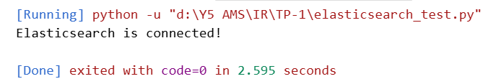

4. Run the following script (after starting Elasticsearch)
from elasticsearch import Elasticsearch

# Connect to Elasticsearch (HTTP mode)
es = Elasticsearch("http://localhost:9200")

# Test connection
if not es.ping():
raise Exception("Connection failed.")
print("Connected to Elasticsearch!\n")

# --- Step 1: Index sample documents ---
docs = [
{"title": "Machine Learning Basics", "content": "Introduction to ML concepts."},
{"title": "Deep Learning Guide", "content": "Neural networks and more."},
{"title": "Python Programming", "content": "Python for data analysis."},
{"title": "Information Retrieval", "content": "Elasticsearch and ad-hoc search."},
{"title": "Data Science Overview", "content": "Statistics and ML applications."}
]

index_name = "books"

# Index documents
for i, doc in enumerate(docs, 1):
es.index(index=index_name, id=i, document=doc)
print("Documents indexed.\n")

# --- Step 2: Perform ad-hoc search ---
query_text = "neural networks"
query = {
"query": {
"match": {
"content": query_text
}
}
}

res = es.search(index=index_name, body=query)

# --- Step 3: Display results with ranking scores ---
print(f"Search results for: '{query_text}'\n")
for hit in res['hits']['hits']:
print(f"Score: {hit['_score']:.4f}, Title: {hit['_source']['title']}")

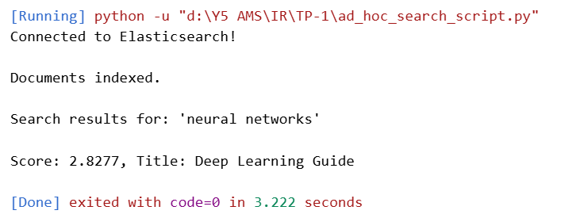

5. Observe ranking scores and explain how Elasticsearch implements ad-hoc search
Elasticsearch is built on Lucene, which implements Information Retrieval (IR) scoring. Here’s a simplified explanation:
Step 1: Indexing
- Documents are tokenized (split into words) and stored in inverted indexes.
- Example: "Neural networks are powerful" → tokens: ["neural", "networks", "powerful"]
Step 2: Querying
- You issue a search query, e.g., "neural networks"
- Elasticsearch matches query terms against the inverted index of documents.
Step 3: Scoring
Elasticsearch uses the BM25 ranking function
Where:
Term | Description
f(t,d) | Frequency of term t in document d
` | d
avgdl | Average document length in the index
IDF(t) | Inverse Document Frequency (rare terms score higher)
k, b | Tunable parameters (default: k=1.2, b=0.75)
- BM25 gives higher scores to documents where query terms are frequent but not too common, and adjusts for document length.
Step 4: Ranking
- Elasticsearch sorts results by _score, returning the most relevant documents first.
- This is why "Deep Learning Guide" scored higher than "Information Retrieval" in our example — it matched query terms more closely.

Key Notes for Ad-hoc Search
- Ad-hoc search = user submits a query at runtime → Elasticsearch evaluates relevance on the fly
- Unlike precomputed search or facets, results are dynamic based on query content
- _score allows you to see which documents are most relevant, making Elasticsearch powerful for IR tasks.

